Vocab for Chapter 11: The Directoire & Empire Period

1. A la Titus (Hairstyle) - Jensen Stenquist

Hairstyles were often based on Greek prototypes, with the hair combed back from the face and gathered in ringlets or coils at the back of the head while the hair around the face was arranged in soft curls. This style of hair was a short, curly style. Bangs were left long over the forehead, and the hair was cropped to the top of the neck in the back. After the Reign of Terror that saw the execution of thousands of people, it became fashionable for the young people to imitate the look of those unfortunate victims who had been put to the guillotine. They cut their hair short the way executioners cut their victims hair to make sure the blade went cleanly through the neck, and tied red ribbon around their neck to indicate the fatal cut.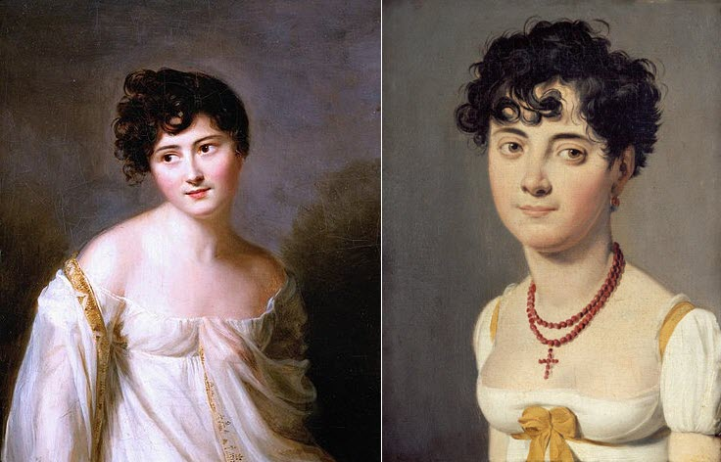

<https://shannonselin.com/2015/05/coiffure-a-la-titus/>

<https://www.amusingplanet.com/2020/04/the-guillotine-haircut.html>

Survey of Historic Costume, Page 317

1. A la Victime (Hairstyle) - Marisa Bone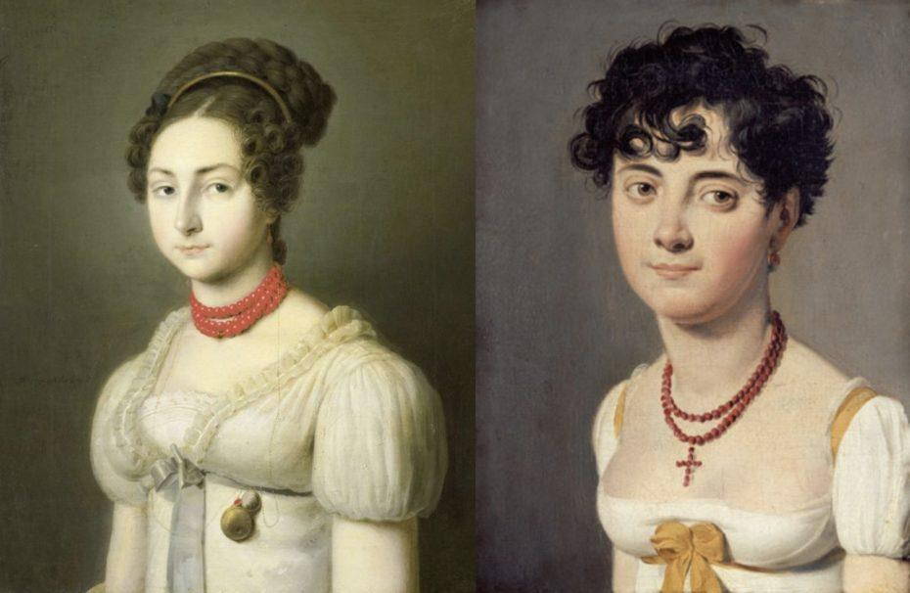

This haircut will never not be iconic and I will never look at a pixie cut the same way again. The A La Victime "like the victim" is a haircut that many fashionable young people in the upper and middle classes adopted that imitated the look of the thousands of people who were executed by the government during the bloodiest period of the revolution. They would sport scarlet ribbons to symbolize the blood of the dead, and cut their hair short the way the executioners cut their victims hair. These people did this to celebrate the fall of the old government while cheering themselves through a horrifying period in history.

[Source](http://www.fashionencyclopedia.com/fashion_costume_culture/European-Culture-18th-Century/Fashion-la-Victime.html#:~:text=During%20the%20later%20years%20of,executed%20by%20the%20government%20during) 1 [Source](https://www.transcriptmag.com/post/coiffure-%C3%A0-la-victime-the-urban-legend-of-the-guillotine-haircuts) 2

1. Bicorne Hat - Alex Clark 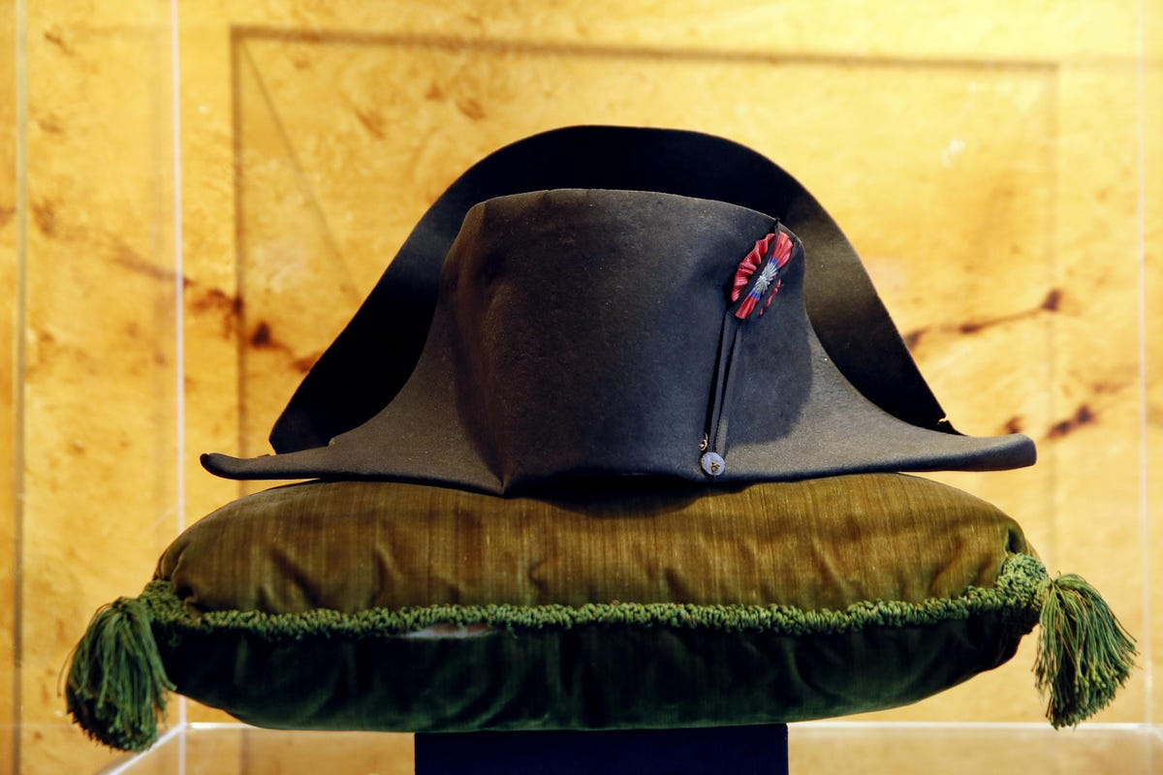

The bicorne hat was a two-pointed hat that could be worn with the points going from front to back or side to side. These hats were typically made with either silk, wool felt, or even beaver fur. During the time it was a hat that was worn by military officials. A bicorne hat could also be called a chapeau bra. They were called this when the bicorne hat was folded flat and was tucked under a person’s arm.

Sources:

Survey of Historic Costume, Page 322

<https://en.wikipedia.org/wiki/Bicorne>

<https://www.talltoad.net/blogs/news/bicorns>

<https://www.forbes.com/sites/guymartin/2021/09/06/napoleons-hat-up-for-auction-in-london-antique-bicorne-bearing-the-emperors-dna-could-fetch-up-to-2-million/?sh=496eb3d05f3e>

1. Bonnet Rouge Hat- Anna Ament

The Bonnet Rouge was a small red hat with political significance. It sat loosely and limply on a person's head. Other names for this hat were the "Phrygian Cap" or the "Red Cap of Liberty." During the French revolution, this cap came to have great and changing significance. Originally, the cap represented freedom and resistance to the oppression that was taking place in France. However, this political message soon got out of hand as revolutionaries began to use the cap as an excuse for their radical behavior. It was all in the name of resisting oppression. Eventually, people began wearing the hat to protect themselves politically. By wearing this hat they were protected from death by guillotine. The cap bonded revolutionists together and some groups even tried to maintain it as a form of dress code. Most men wore the hat, but some extremist women began wearing the hat. These women were feared and looked at as radicals. 

<https://www.thoughtco.com/phrygian-cap-bonnet-rouge-1221893>

<https://mycostumehistory.wordpress.com/tag/bonnet-rouge/>

1. Carmagnole - Abbie Burns

The carmagnole was worn during the French Revolution. The name comes from a song and dance from the revolution. The song was called *La Carmagnole*. The well known pesaunt outfit began in South Paris and made its way over to South France during the Revolution. Working class men wore a short cloth or wool jacket, with metal buttons, typically a dark color. It fell at the hip and was full in the back with a smock like cut. 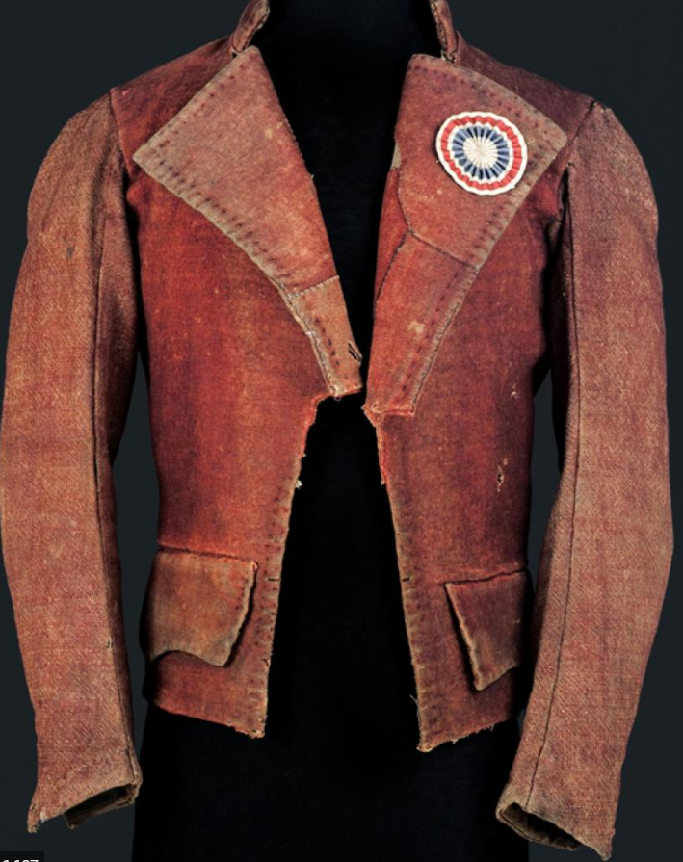

Source:

Book pg: 309

<https://www.palaisgalliera.paris.fr/en/work/carmagnole-jacket>

<https://www.britannica.com/art/carmagnole>

1. Cossacks-Debbi Wright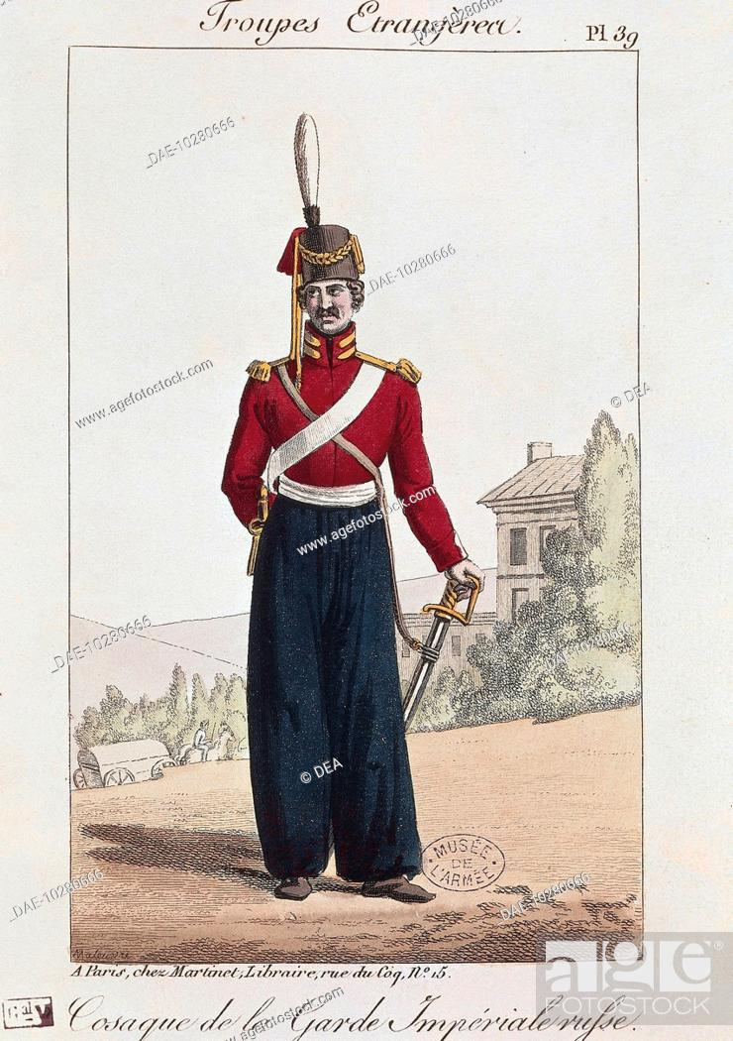

From our textbook we learn that the trousers of the Russian soldiers in the 1800s were called cossacks. These cossacks were extremely full. You can see from the illustrations above that they were worn outside of the boot and tucked inside of the boot. At times the cossack trousers had wide stripes of color green or blue that served as part of the dress uniform.

<https://www.google.com/search?q=russian+soldier+cossack&tbm=isch&chips=q:russian+army+cossacks,g_1:19th+century:4oGVRyjeJHQ%3D&hl=en&sa=X&ved=2ahUKEwiG1YqT24T2AhUMATQIHcIzCsgQ4lYoAnoECAEQIA&biw=1349&bih=625#imgrc=wdwTmFmawAFK3M&imgdii=9N5Xm-8au4720M>

<https://www.google.com/search?q=russian+soldier+cossack&tbm=isch&chips=q:russian+army+cossacks,g_1:19th+century:4oGVRyjeJHQ%3D&hl=en&sa=X&ved=2ahUKEwiG1YqT24T2AhUMATQIHcIzCsgQ4lYoAnoECAEQIA&biw=1349&bih=625#imgrc=wdwTmFmawAFK3M>

<https://en.wikipedia.org/wiki/Cossacks#Uniforms>

Toratora, Phyllis G, and Keith Eubank. *Survey of Historic Costume, 5th Edition*. Berg, 2009.

1. Dandy : Elizabeth Nathan

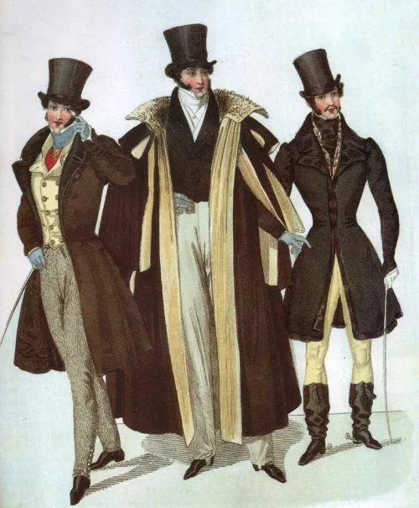

A Dandy is a man who places particular importance upon physical appearance, refined language, and leisurely hobbies. A Dandy could be a Self-made man who strove to imitate an aristocratic lifestyle despite coming from a middle-class background, especially in late 18th- and early 19th-century. Historically, dandies were very conscious of how they were perceived by others, refining their mannerisms, body language and voice to maintain a nonchalant demeanor.

<https://www.flaneurlife.com/dandy/>

[https://en.wikipedia.org](https://en.wikipedia.org/)

1. Reticule- Abigail Storrer

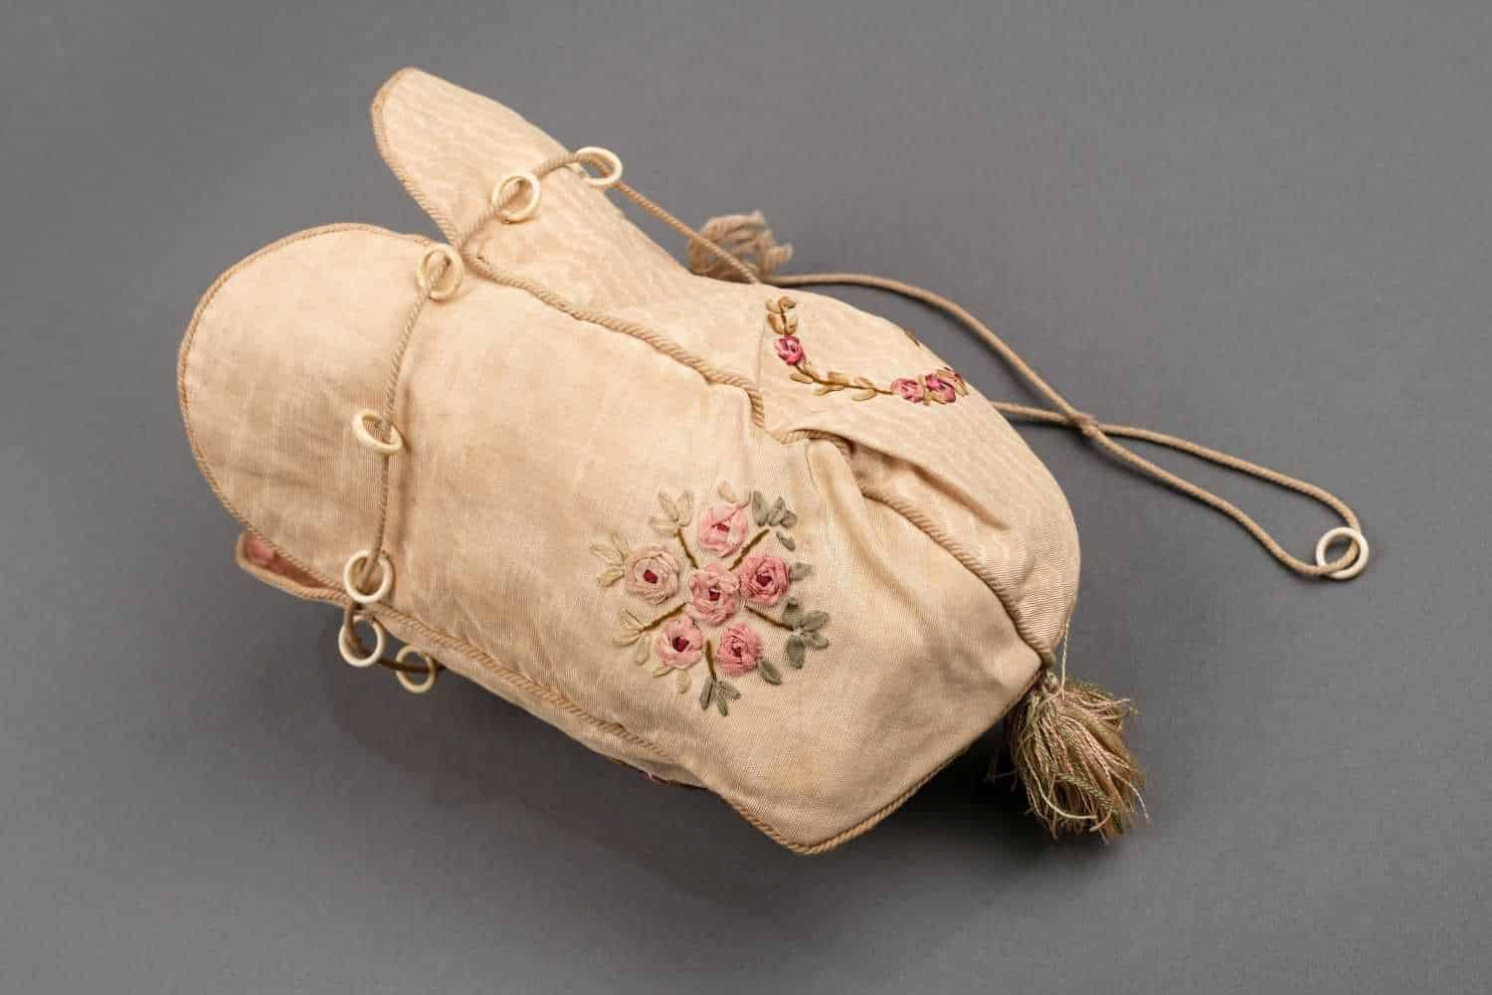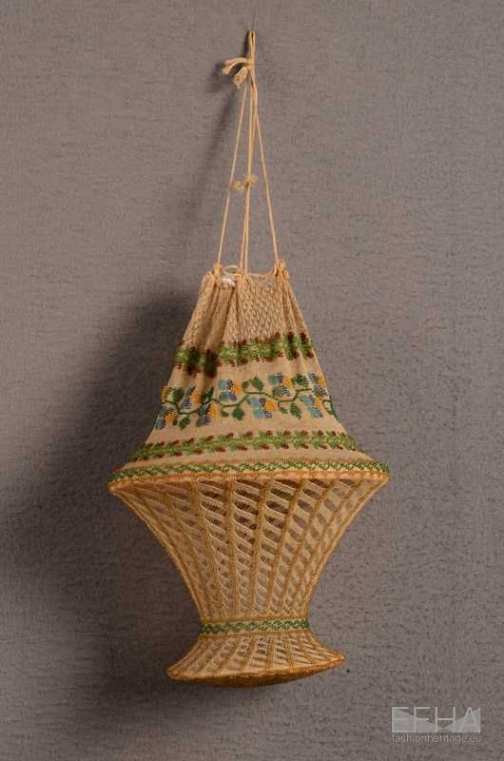

A reticule was an accessory that became necessary when the style of dresses changed. Empire dresses were not convenient to have pockets on so a reticule was created as a purse. Another name for them mentioned in the textbook is indispensibles. These small purses usually had a drawstring closure and would be made out of silk, velvet, or leather. These are kind of like a forerunner of today's purses but at first were not immediately accepted because before a ladies pockets were hidden. To carry around a bag was considered something that a man would do and was not as ladylike too.

Tortora, P. G., & Eubank, K. (2010). *Survey of historic costume: A history of western dress*. Fairchild.

<https://maggiemayfashions.com/calicoball/fashionhistory/the-late-georgian-empire-regency-era-1790-1820/>

<https://fashionheritage.eu/accessories-ancestors-reticules/>

1. Quizzing glasses- Jessica Fraser

It was a very popular item to have. It was normally circular shaped glass surrounded by gold or silver edging. It could be used for better vision and for accessories. The handles could be very elaborate. This means some were made from locks of hair or more gold and silver. It was also to help assist those with poor vision. It dangled from the neck with a long ribbon, that way you could wear it everywhere you went.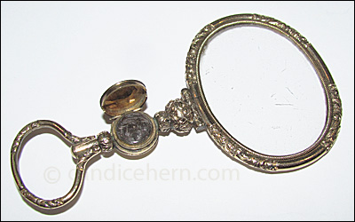

The Book

<https://candicehern.com/regencyworld/quizzing-glasses/>

[(Links to an external site.)](https://candicehern.com/regencyworld/quizzing-glasses/)

<https://thecozydrawingroom.com/2013/04/24/the-power-of-the-quizzing-glass/>

1. tricolor ribbon cockade- Samantha Hooper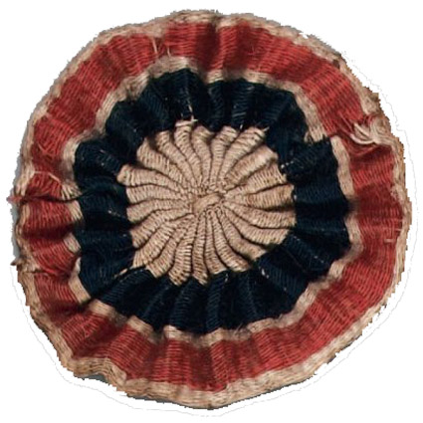

The tricolor ribbon cockade was the symbol of the French Revolution. They were red, white, and blue, which represented the clergy(blue), nobility(white), and third estate(red). They became the official symbol of the Revolution. It was originally designed by Camille Desmoulins. They were typically worn on hats.

<https://www.britannica.com/art/cockade-hat-decoration>

<https://en.wikipedia.org/wiki/Cockade_of_France#:~:text=The%20tricolor%20cockade%20became%20the,the%20third%20estate%20(red)>

1. Toques - Jocelyn Munoz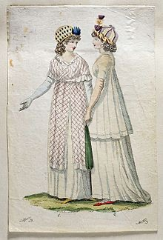

Toques were high, brimless hats that used to be worn by both men and women but by this time were most likely only worn by women because of how decorative they became. They would be decorated in many ways either trimmed with things like lace or fur. Or they could be decorated with bows or simply made with a more expensive material.

Tortora, P. G., & Marcketti, S. B. (2021). In Survey of historic costume. essay, Fairchild Books.

https://en.m.wikipedia.org/wiki/Toque

<https://www.britannica.com/topic/toque>

1. Chapeau - Aubrey Reidhead

This two-pointed hat was called chapeau bras which is the French word for “hat for the arm.” They were made from more expensive fabrics or pelts such as silk, wool felt, or felted beaver mixed with wool. Some were decorated with feathers from ostriches or other birds. The hat was specifically designed to be flattened and carried under the arm without injury. Some of the hats would have ribbon trimming or other decorations to them.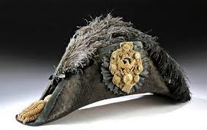

[National Museum of American History](https://americanhistory.si.edu/collections/search/object/nmah_1059707)

[Philadelphia Museum of Art](https://www.philamuseum.org/collection/object/138524)

1. Spencer- Andrea Lazaro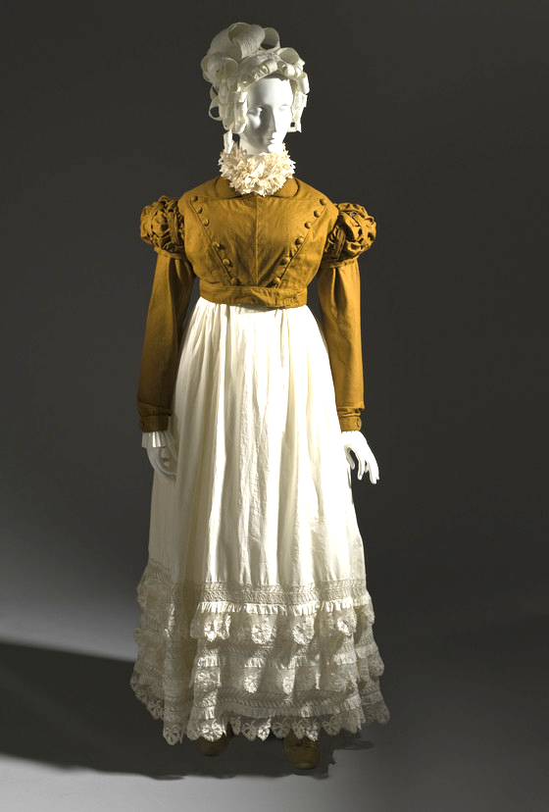

The Spencer was a piece of clothing worn both by men and women. It was a jacket that ended at the waistline. There are three different versions on the story of this jacket: According to all of them Lord Spencer was responsible for creating this new fashion by cutting the end of his jacket, though the real reason why he did that is unclear. It could be either sleeve or sleeveless, mostly worn outdoors and of contrasting colors to the rest of the costume.

Sources:

Survey of Historic Costume p. 316

<https://es.wikipedia.org/wiki/Spencer_(indumentaria)>

<https://fashionhistory.fitnyc.edu/spencer-jacket/>

Spencer - Bailey Pinder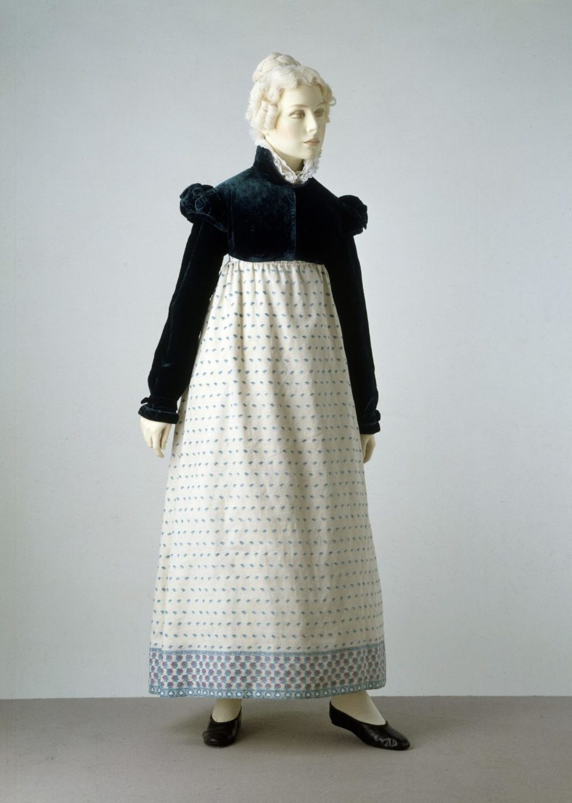

A spencer was a short jacket. It was worn by both men and women and it ended at the waistline. For men it went to the natural waist, bot for women it meant it ended right under the bossom. Some were emant for outdoor wear, while others were meant only to be worn inside.

<https://fashionhistory.fitnyc.edu/spencer-jacket/>

[**https://www.apparelsearch.com/terms/s/spencer_jacket_term.html**](https://www.apparelsearch.com/terms/s/spencer_jacket_term.html)

The Book, pg 316

1. Sans Culottes - Hannah Ferreira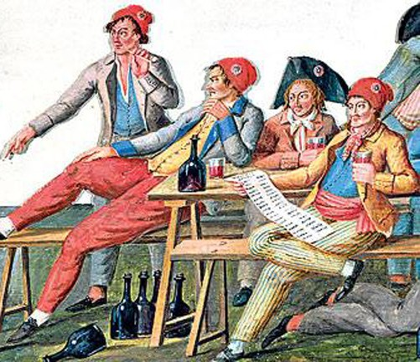

Known to be the “heart and soul” of the French Revolution.

Sans Culottes translated means “without knee breeches”. Only the nobility and the more affluent wore knee breeches, so the working class all wore trousers. This name was symbolic of their position in the revolution. They were known to be violent and vicious. “They wore a carmagnole, a short woolen or cloth jacket of a dark color. It was hip length with fullness at the back, cut rather like a smock. Trousers were made of the same material or of a red, white, and blue striped drill. A red waistcoat was worn, and wood shoes called clogs or sabots. A soft woolen peasant’s cap of red color was worn with this costume” (309).

Book

<https://alphahistory.com/frenchrevolution/sans-culottes/>

https://historycooperative.org/sans-culottes/

1. Merveilleuses - Kimberly Tesam Moita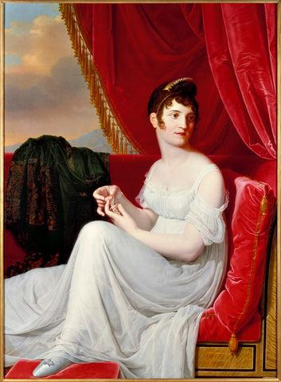

Merveilleuses and Incroyables were part of the “young trendy kids” of the 19th century, and Merveilleuses (meaning the marvelous ones) were women who wore the most extreme of styles during the Directoire in France after the French Revolution. These women’s gowns had long flowy trains, the sheerest of fabrics, low necklines almost to their waists in some cases, and large exaggerated caps. They had a lot of influences from the greeks and the romans, so it took on simple silhouettes and the women started to wear less undergarments. Soft, clingy, sheer fabrics like muslin, linen were used as well as pink tights to show off their legs (Their style was widely criticised). The empire waist was also employed, with dresses having the waistline right underneath the breasts.

<http://www.fashionencyclopedia.com/fashion_costume_culture/European-Culture-18th-Century/Incroyables-and-Merveilleuses.html>

<https://www.metmuseum.org/art/collection/search/367840>

<https://www.nytimes.com/2016/08/17/t-magazine/fashion/fashion-as-protest-french-incroyables.html>

1. Round gown - Esther Wambold
2. Pantalettes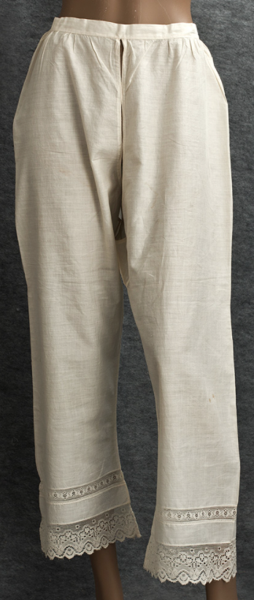

Pantalettes originated in France and were worn under their dresses to make sure the legs were covered modestly in case they got exposed. Styles varied from one to two pieces made with lace and buttons. Pantalettes were knee length and the crotch was left open for hygiene reasons. At times these were worn under shorter skirts so that they would show slightly underneath.

<https://en.wikipedia.org/wiki/Pantalettes>

Survey of Historic Costume p. 317

<https://fashionhistory.fitnyc.edu/pantalettes/#:~:text=Pantalettes%20originated%20in%20France%20in,of%20leggings%20or%20long%20drawers.&text=Ankle%2Dlength%20pantalettes%20for%20women,covered%20should%20they%20become%20exposed>.

1. Habit shirt- Brittany Pocock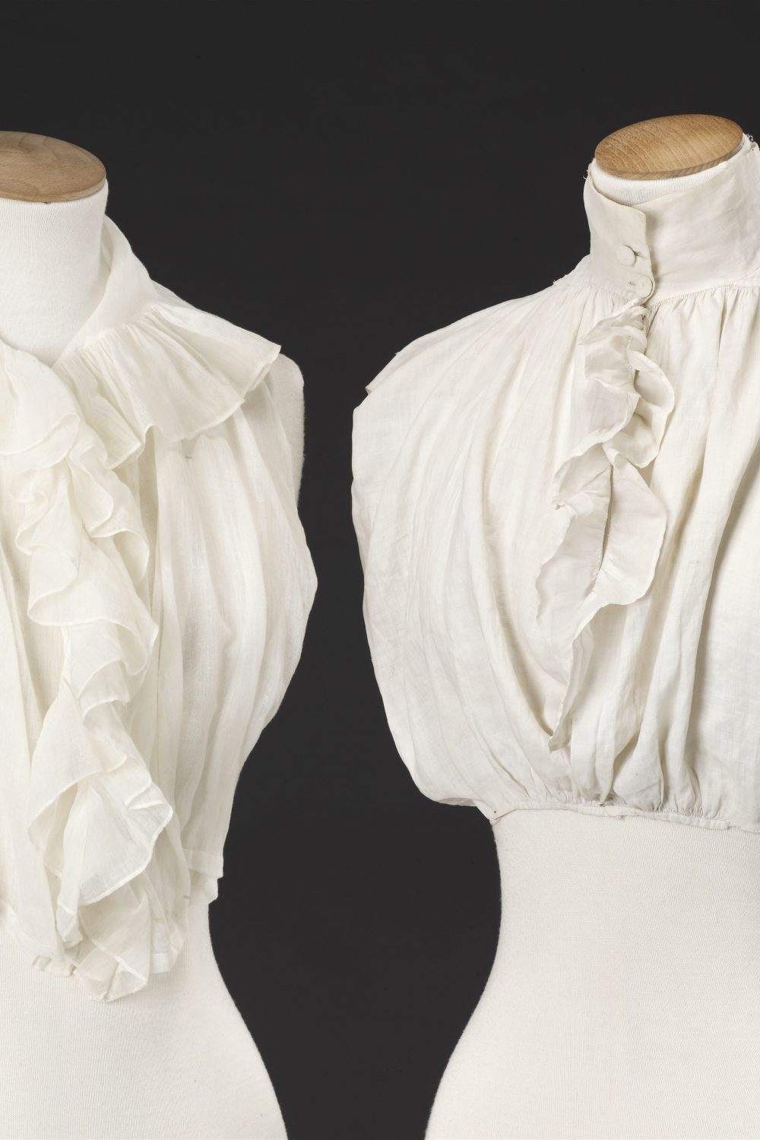

These shirts were based off of shirts that men wore. They were worn underneath an outer garment. The shirt developed from shirts formerly worn by women under the jackets of their riding habits. It had ruffles and the collar was fastened with two fabric covered buttons. It was made from fine cotton muslin.

Book

[Habit Shirts — The John Bright Collection](https://www.thejohnbrightcollection.co.uk/costume/habit-shirts/#:~:text=Habit%20Shirts%20Late%2018th%2F%20Early%2019th%20Century%20Linen%3B,women%20under%20the%20jackets%20of%20their%20riding%20habits.)

[Historical Costume 1800-1850 : the Lady's Riding Habit - Liberta Books](https://libertabooks.com/costume/historical-costume-1800-1850-the-ladys-riding-habit/)

1. Cravat- Savannah Tanner 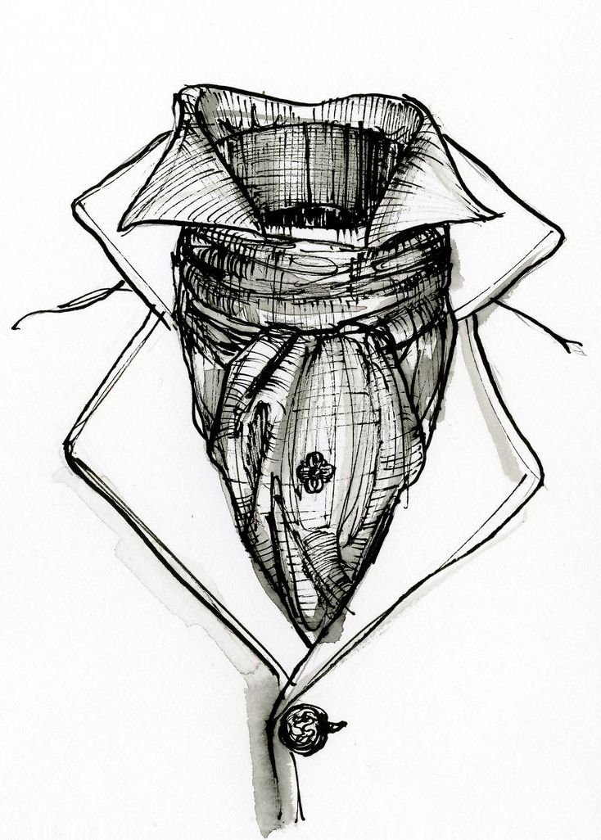
   1. A cravat was a neck accessory consisting of large squares of fabric that you would fold and wrap around your neck and tie in the front. The cravat may have come about around the Thirty Years War and originated in the military. The cravat became popular with English nobility. You could accessorize your cravat with jewelry and embellishments. Today we know the cravat as a formal scarf.
   2. Pg. 319
   3. <https://www.britannica.com/topic/cravat>
   4. <https://tweedmaker.com/blogs/blog/history-of-the-cravat>
2. High Stomacher Dress- Ida Johnson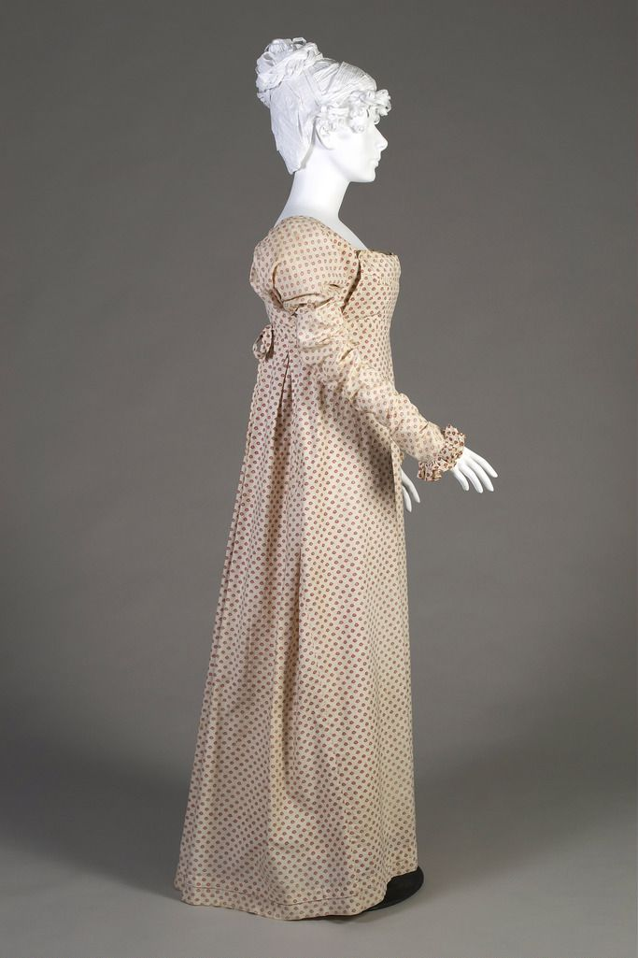

Was a complex construction that mimicked a dress with an apron in front. The bodice was sewn to the skirt at the back only with a bib-like application to be pinned at front and then a ribbon or string to tie it around back at the waist. It is also called a Regency Apron Front Dress.

Book Pg 316

Is also demonstrated in the Jane Austen Wardrobe video.

1. Pelisse- Marisol Dejesus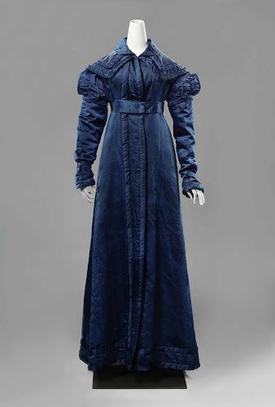

The pelisse is a fur-lined coat, similar to a modern coat, especially for winter. It was made for the outdoors to keep the body warm. The pelisse was a full length coat that followed the Empire silhouette, which has a high waistline below the bust. It was made from silk or cotton. The pelisse is a garment for outdoors.

Book pg.316

<https://fashionhistory.fitnyc.edu/pelisse/>

​​<https://www.metmuseum.org/art/collection/search/82141>

1. Gypsy Hats - Irelynd Preece

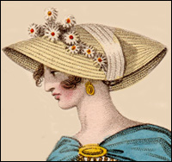

The Gypsy hat was a woman's hat with a low crown and a moderately wide brim. These hats had a ribbon tied over the outside of the brim and under the chin to keep the hat on. Gypsy hats were comparable to Toques and day caps. Toques were high, brimless hats very similar to Gypsy hats. Day caps were worn by mature women and were small muslin or lace caps.

Sources:

Textbook page 317

<https://quizlet.com/140298303/history-of-costume-19th-century-1789-1820-directoireempireregency-period-flash-cards/>

<https://www.chegg.com/flashcards/exam-2-chapters-9-11-73c6ad67-3d70-40da-8b0c-ccb544afc12c/deck>

1. Day Caps- Jamie Rakes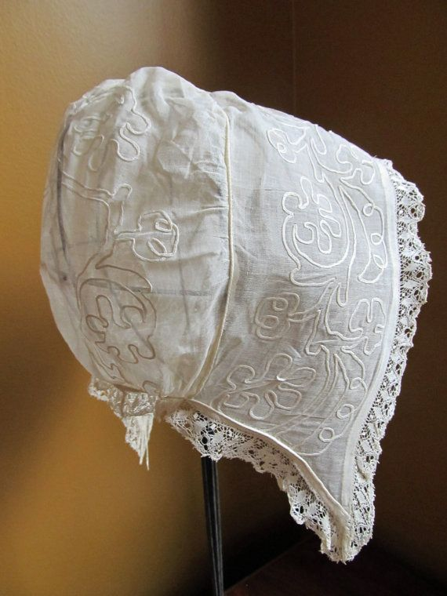

The day cap is something you see all the time during this time period. Often it is the hat that is worn on a day to day basis by women. The women who wore these caps were mature women. They were worn indoors and usually made of Muslin or lace. Mature women were those who were introduced to society or married. Young girls did not wear these caps. These caps were only worn while indoors and not while they were out other hats would be worn for different occasions.

<https://janeausten.co.uk/blogs/womens-regency-fashion-articles/regency-caps-draped-and-ruffled>

<https://janeaustensworld.com/2008/02/22/bonnets-caps-and-hats-a-regency-fashion-accessory-no-lady-can-do-without/>

1. Stocks- Lauren Shumway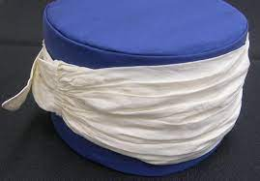

A neck band that was stiffened was worn by men. The stock wrapped around the neck multiple times and tied or buckle at the back of the neck

The book page 319

<https://janeausten.co.uk/blogs/mens-fashion/neckcloths-cravats-stocks-solitaires-jabots>

<https://en.wikipedia.org/wiki/Stock_tie#:~:text=A%20stock%20tie%2C%20or%20stock,a%20style%20of%20neck%20wear.&text=Another%20type%20of%20stock%20is,hunt%20or%20certain%20competitive%20events>.

1. Pantaloons - Jalissa Cloward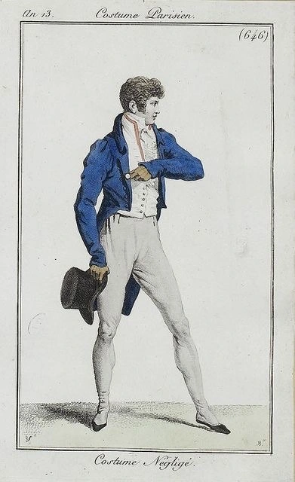

Pantaloons were more fitted to the leg than trousers. They sometimes had an instep strap to keep them from rolling or riding up the leg. Sometimes the pantaloons were buttoned all the way down the leg.

*Survey of Historic Costume* pg. 321

<https://janeaustensworld.com/2013/06/21/regency-fashion-mens-breeches-pantaloons-and-trousers/>

<https://www.historyundressed.com/2013/11/history-of-mens-leg-wear-pants-through.html>

Pantaloons- Hailey Child

Pantaloons were more form fitting and less loose than other types of trousers. Generally worn by men, they were fastened with buttons around the lower part of the calf and even occasionally tied with ribbons. 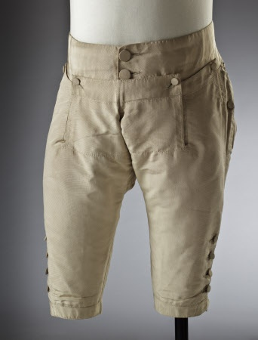

<https://www.wordnik.com/words/pantaloons>

Book

<https://www.thefreedictionary.com/pantaloons>

1. Top Hat: Lena Kawakami 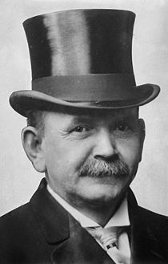

Top hats could be tall or short and they had a brim that was slightly turned up. It was typically worn by richer people and made of silk. They started out 16-17 cm tall and then got shorter 12-13 inches tall, the brim was about 2 ½ inches wide

<https://theconversation.com/amp/the-story-of-the-top-hat-26215> <https://www.silktophats.eu/historytophat.html>

1. Incroyables - Savannah Jeppson

The Incroyables were men who were extremists in the Neoclassical revival period. They wore waistcoats that were loosely fitted, especially at the shoulders, excessively tight breeches, and neckties/collars that covered their chins. Some wonder if they were even able to hear the men speak through so much fabric covering their mouths. Their hairdress was shaggy and unkempt to match their outfits.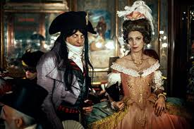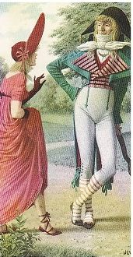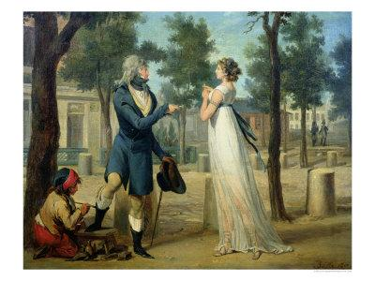

Sources:

The Book

<https://www.metmuseum.org/art/collection/search/367840>

<https://en.wikipedia.org/wiki/Incroyables_and_merveilleuses>

1. Reticules - Kya Boyd 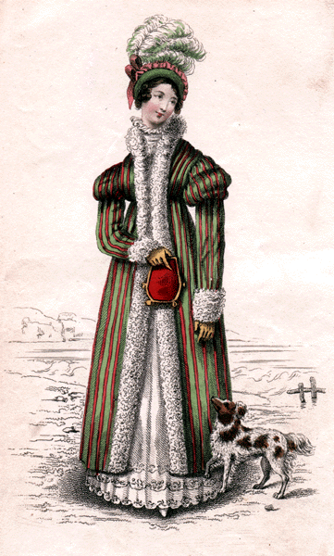

Reticule also known as reticulum meaning net in Latin language is a small women’s handbag originally netted. This became very popular in the late 18th century and as time went on reticules were made from various fabrics. Some fabrics included velvet, silk, and satin with embroidery or beading to decorate the bag. This bag has a drawstring closure that can be carried over the arm on a cord or chain sometimes trimmed with embroidery or beading.

Sources: 1.<https://en.m.wikipedia.org/wiki/Reticule_(handbag)> 2.<https://daily.jstor.org/a-mini-history-of-the-tiny-purse/>

“Survey of Historic Costume”

1. Madison Frost: A spencer- This is a short woolen outer tail coat usually worn by women and men. The man's Spencer was a double breasted, short waist length. It is believed to be started by George Spencer, who is said that his tail coats were burned by a fire. It would later be used by British military soldiers and got the name, mess jacket. It would also be adopted by women and would be worn as a cardigan. It had an empire waist, and would be tailored identically to the dress that was worn.

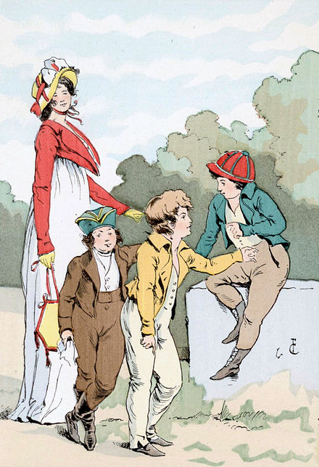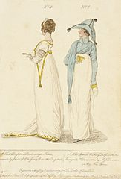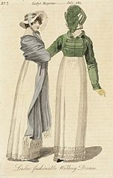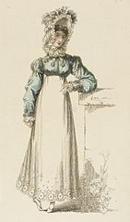

Textbook

https://en.wikipedia.org/wiki/Spencer_(clothing)

1. Spencer - Claire Lynes

A Spencer is an outerwear jacket that stops at the waistline. It was favored by women because it kept the feminine silhouette and went with the waistlines trends of the time. But the Spencer was worn by both men and women. It most commonly had long sleeves and could be worn buttoned up or unbuttoned to be more risqué. The Spencer was also commonly worn in a contrasting color. This trend was started by Lord Spencer who cut his jacket at this length. 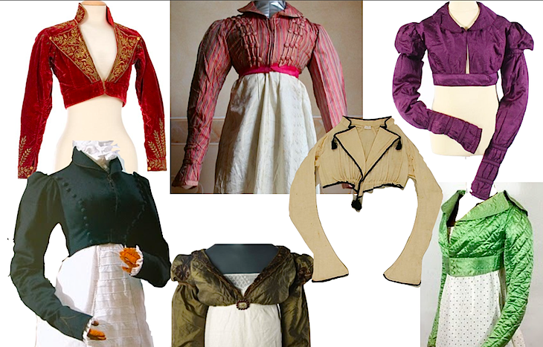

Sources

Survey of Historic Costume p. 316

<https://janeaustensworld.com/category/the-spencer-jacket/>

<https://libertabooks.com/costume/historical-costume-1800-1820-spencer/>